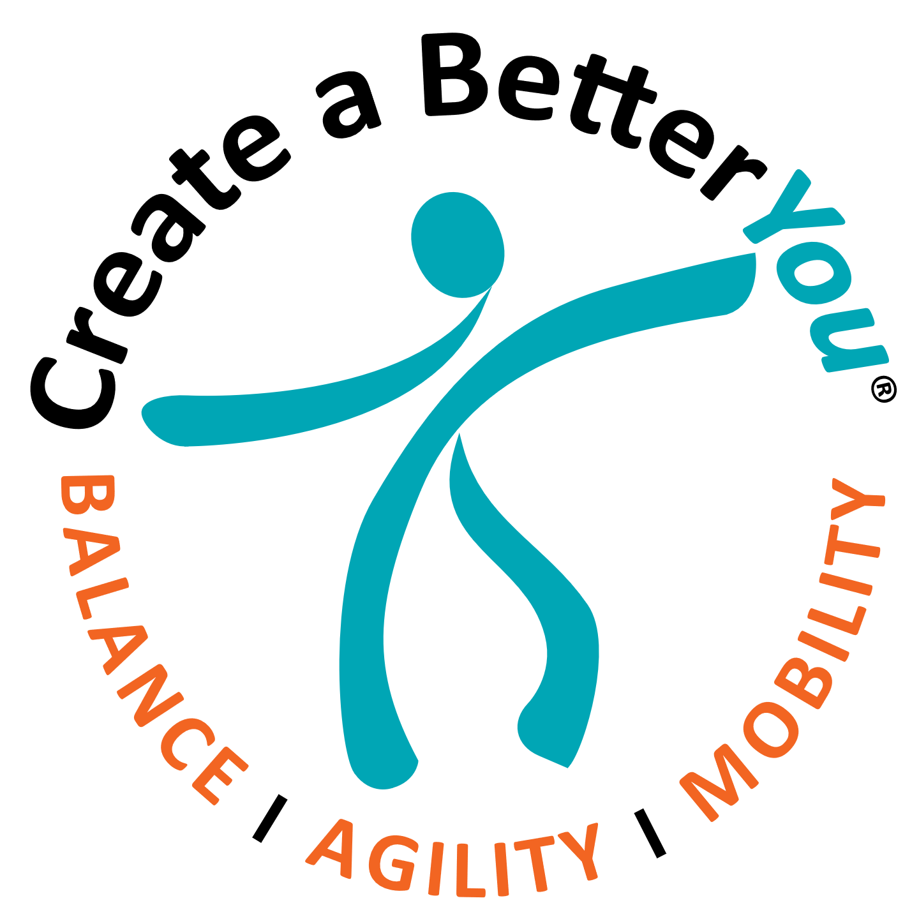
THANK YOU FOR DOING YOUR PART TO PREVENT FALLS USING THE POWERFUL TOOL OF EDUCATION!

FREE COURSE

INTRODUCTION TO BALANCE, MOBILITY AND FALL PREVENTION
(click to register)

FALL PREVENTION BUNDLE ($20)
INCLUDES

MEDICATIONS AND FALL RISK

(APPROVED FOR 1 CEU FOR OHIO RNs, PTs, AND OTs)
Plus

INTRODUCTION TO BALANCE, MOBILITY AND FALL PREVENTION
(click to register)

Offer expires October 31, 2019

